- Feux Verts Screen
  - Interface
This screen will be display when clicks on “Maintenance & Setting Menu”
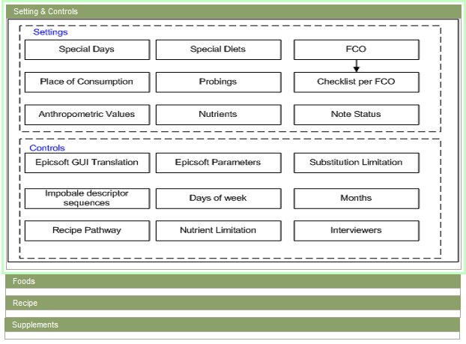
- Feux Verts – Controls & Settings
Missing screen: substitution at descriptor level with controls
If perimeter = Library then “interviewers” has to be deleted
If perimeter = Project then keep only special day, special diet, FCO, place of consumption, probing list, anthropometric values, nutrient, Note status, Epicsoft Parameters, Substitution limitation at group/subgroup level.
If perimeter = Country then keep only Check-list by FOC and interviewer list

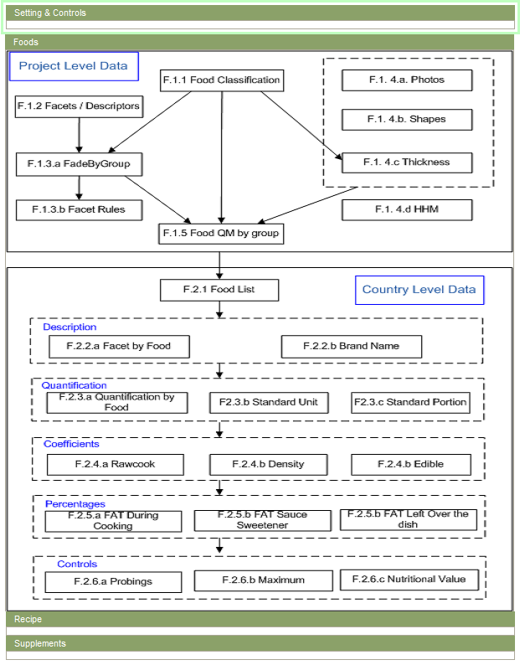
Missing on screen: at project level; probing by groups/subgroups
- Feux Vertes – Foods

We propose you another way to present the different screens by adding several arrows in order to better understand the links between the data. See below.
If perimeter = Library then all the blue blocks are displayed
If perimeter = Project then all the blue blocks are displayed
If perimeter = Country then all the blocks (blue & green) are displayed.
Perhaps, it can be interesting to have 2 icons in front of each blocks to specify if the screen is open or not.

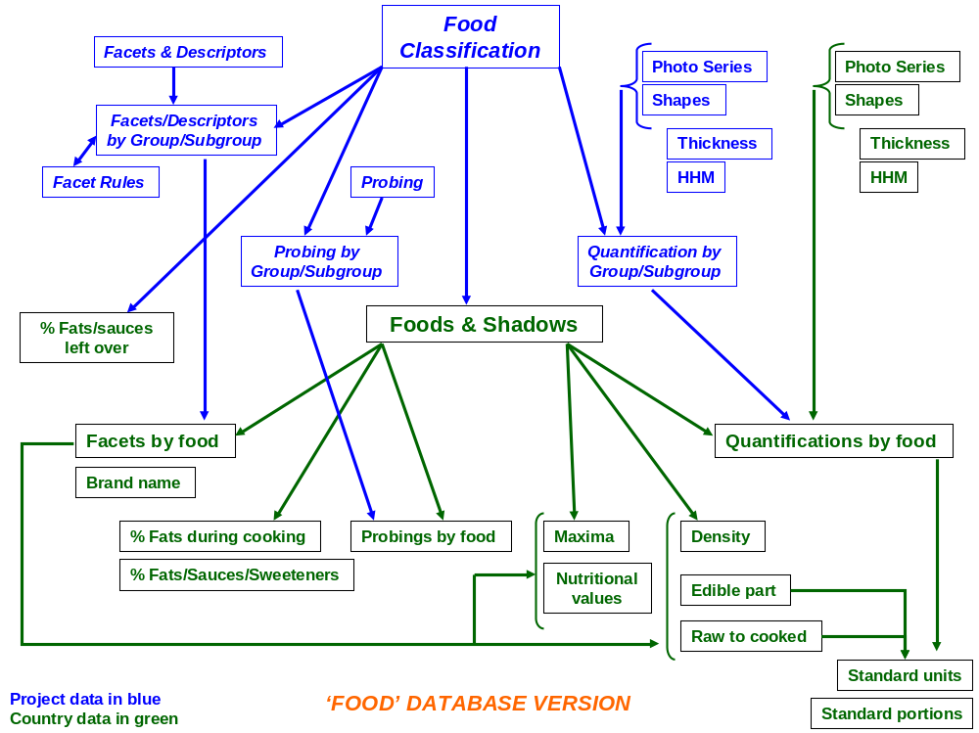
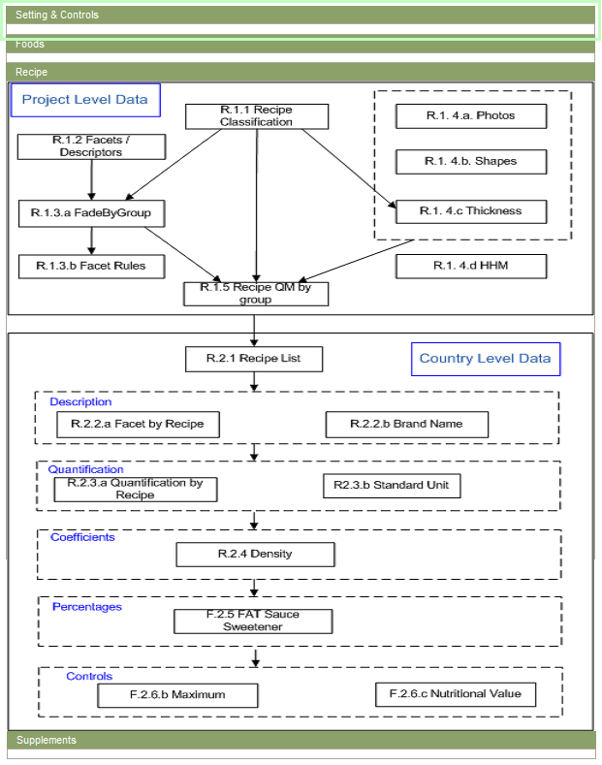
Missing screen: at project level; probing by groups/subgroups. At country level, recipe ingredients and probing per recipe screens

- Feux Vertes – Recipes
As for Foods, here a proposal for Recipe and supplement part.
If perimeter = Library then all the blue blocks are displayed
If perimeter = Project then all the blue blocks are displayed
If perimeter = Country then all the blocks (blue & green) are displayed.
Perhaps, it can be interesting to have 2 icons in front of each blocks to specify if the screen is open or not.
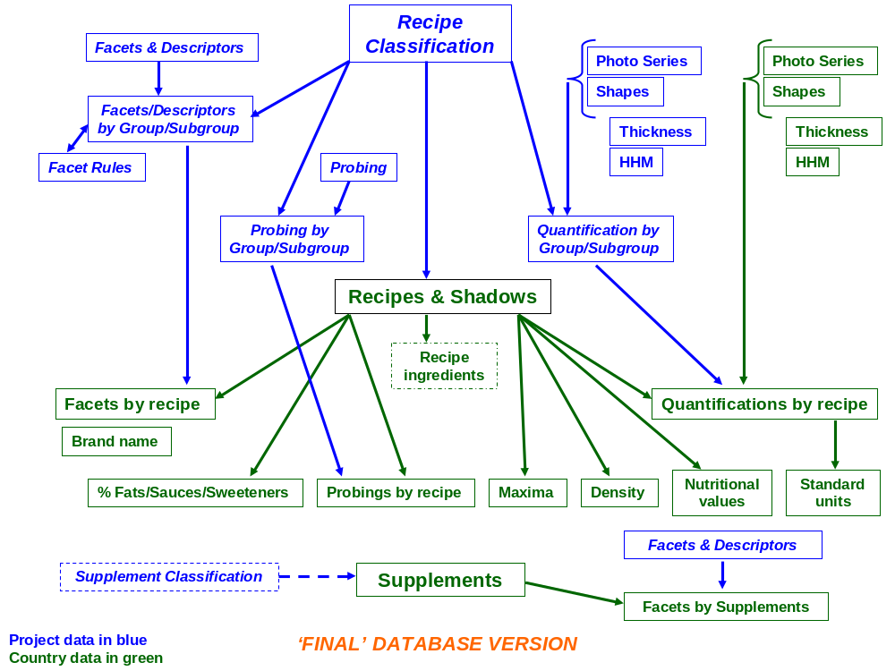

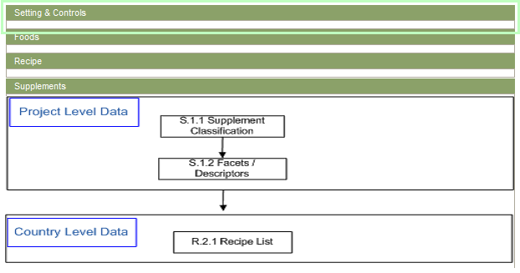
No link between supplement classification and facets / descriptors (delete the arrow)
Change recipe list per supplement list and description
- Feux Vertes – Supplement
This screen is displayed based on the current Perimeter.
- In Project Level: The Project Level Data will be displayed, Country level is hidden
- In Country Level: The Country Level Data will be display, the Project Level is collapsed but user can expand it.
- In Library Perimeter : Same with Project Level but some blocks will be disabled and some activated (e.g. Epictext=GUI translation)
  - Management
- User with special permissions will have right to access this screen, in this case all blocks will be visible
- Each Block will be corresponding with 1 screen in e-SMP. It’ll have the following status:
- Open: Open for modification
- Closed: Locked for modification
- Double click on each block:
- If user has right to open screen → open the screen
- If not → Display error message
- Users with special permissions will have right to change status of these blocks by click on them.
IARC: If possible, can we have another way to change the screen/table status rather than using the right click of the mouse (e.g. having a checkbox…)? Effectively, the right click is not obvious and we will need to train the users… instead a screen button is visible…

- We’ll use background color to separate the status for all blocks:
- Open: Green
- Closed (has data): Orange
- Closed (no data): Grey
- Tooltip of each block (Performance Impact): When points mouse to each block the tooltip will be displayed. Tooltip contains:
- Number of Records
- Number of Validated records (with validated Translation)
- Context Menu when right click on each block:

This is example of context menu when right clicks on Food Coefficients:
Status | Open
 | Locked

IARC: when a screen is locked, that means that on menu, the screen cannot be open OR the screen can be opened and the available data can be accessible in view mode only (no add, delete update possible)?

